Angus Prevention & Proactive Care Programme
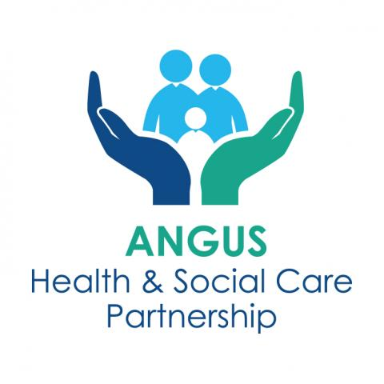
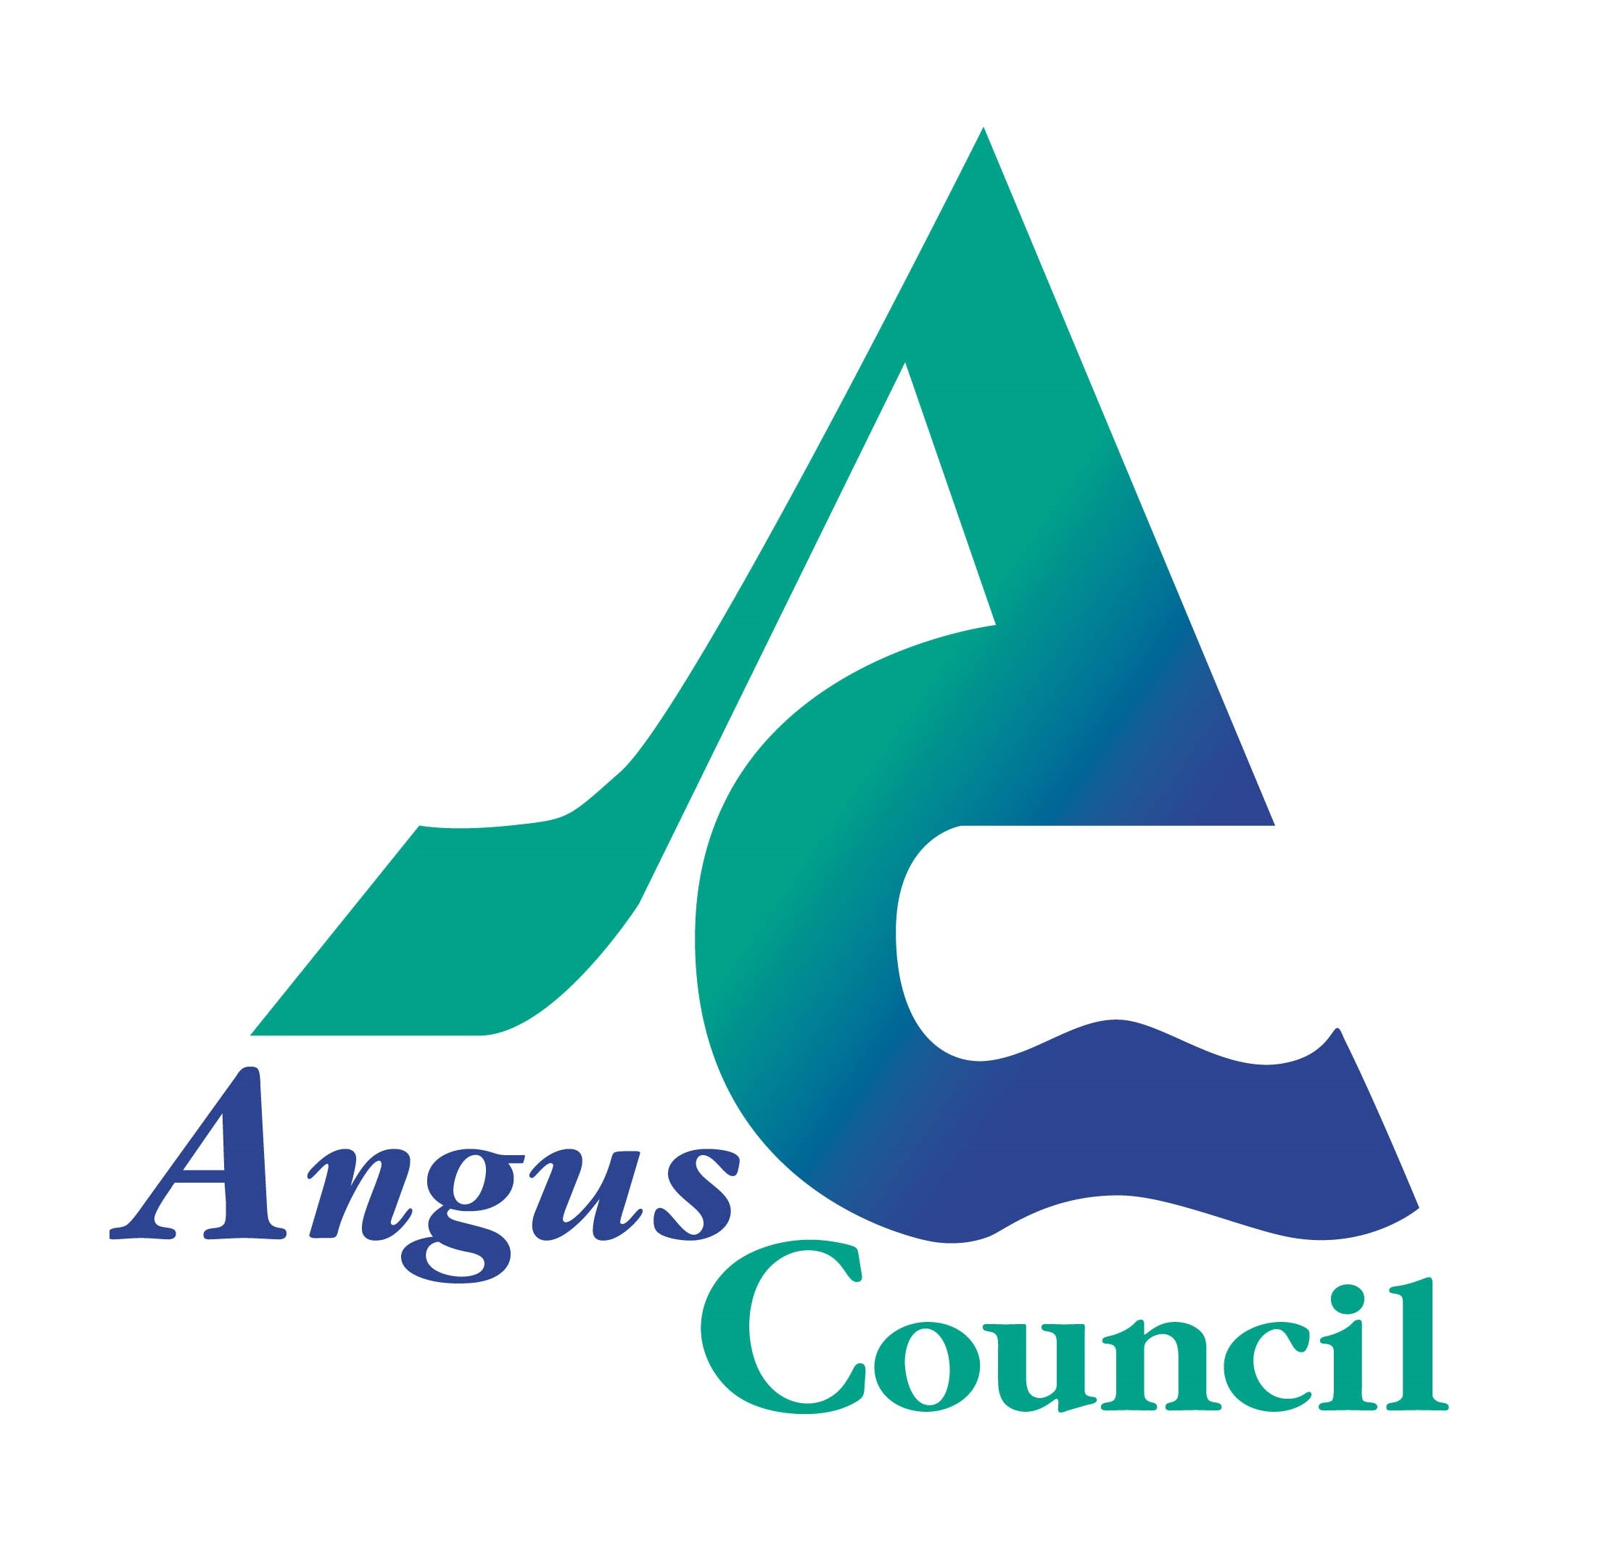


A suite of non-medical tools and interventions to support
people with living better, for longer in Angus

ANGUSalive – Be Active…Live Well Physical Activity Referral Programme

This programme supports those who are living with, or at risk of, long term physical and mental health conditions to become more active. Participants can self-refer or can be referred by their health professional.
Active Start is for the most inactive in our communities and provides a free 12 week structured programme of medium – high level support, combining low-level activity with informal discussions on various topics that can support a healthy lifestyle.
Stay Active offers a range of bookable classes suitable for Active Start graduates, or for those who are already active and need less support to continue their activity.
For information and referral form, scan QR code or: https://angusalive.scot/sport-leisure/be-active-live-well/

Lifestyle Management Courses
The sessions bring together people who are living with long term conditions and support them to develop coping strategies - this course can help individuals to learn techniques and skills that will help to reduce stress and provide the tools needed to live well and manage better. Each course is 10 weeks long.
The next block of classes is being delivered in Arbroath beginning 26th June 2024.
For more information or to book a space, please email tay.anguslmc@nhs.scot or call 01241 822585

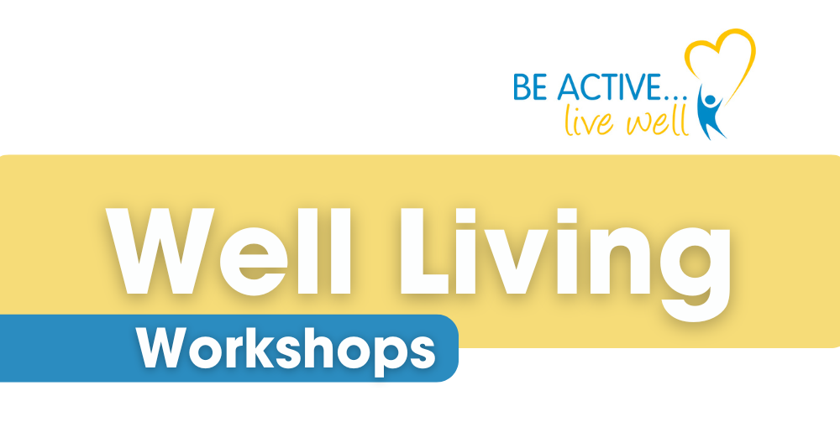
ANGUSalive – Well Living Workshops
Delivered by the Health & Wellbeing Team, these workshops will run monthly until March 2025. Each workshop will focus on a particular topic related to our health and wellbeing and include educational talks and discussion, as well as taster sessions and community partner information.
More information and timetable of workshops here:
https://angusalive.scot/sport-leisure/be-active-live-well/well-living-workshops/

Angus Community Connector
The Angus Community Connector app helps you find all third sector organisations, services, community groups and social enterprises, in your area of Angus. This app, managed by Voluntary Action Angus, is a great resource for those looking for what is available in their area. We also have links to Angus wide services and national services and a form for adding new services.
To use the online version or find links for the mobile app, visit: https://anguscommunityconnector.org.uk/

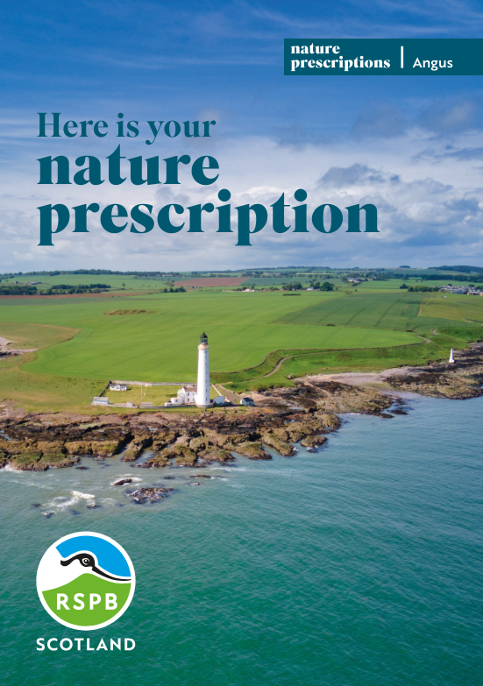
Nature Prescribing Calendar
An Angus Nature Prescribing Calendar has been developed to help people in Angus see the physical and mental health wellbeing benefits of nature and provide plenty of local ideas to encourage people to get outdoors.
The calendar, full of seasonal activities around Angus has been developed in partnership with local groups and organisations to support local people living with various common health and wellbeing conditions, such as anxiety and depression, and encourages an increase in physical activity.
You can request a copy from your GP practice or local Community Link Worker team at Voluntary Action Angus, The Cross, Forfar.
Or download here: https://www.angushscp.scot/wp-content/uploads/2023/09/NHS-nature-calendar_FINAL-A5.pdf
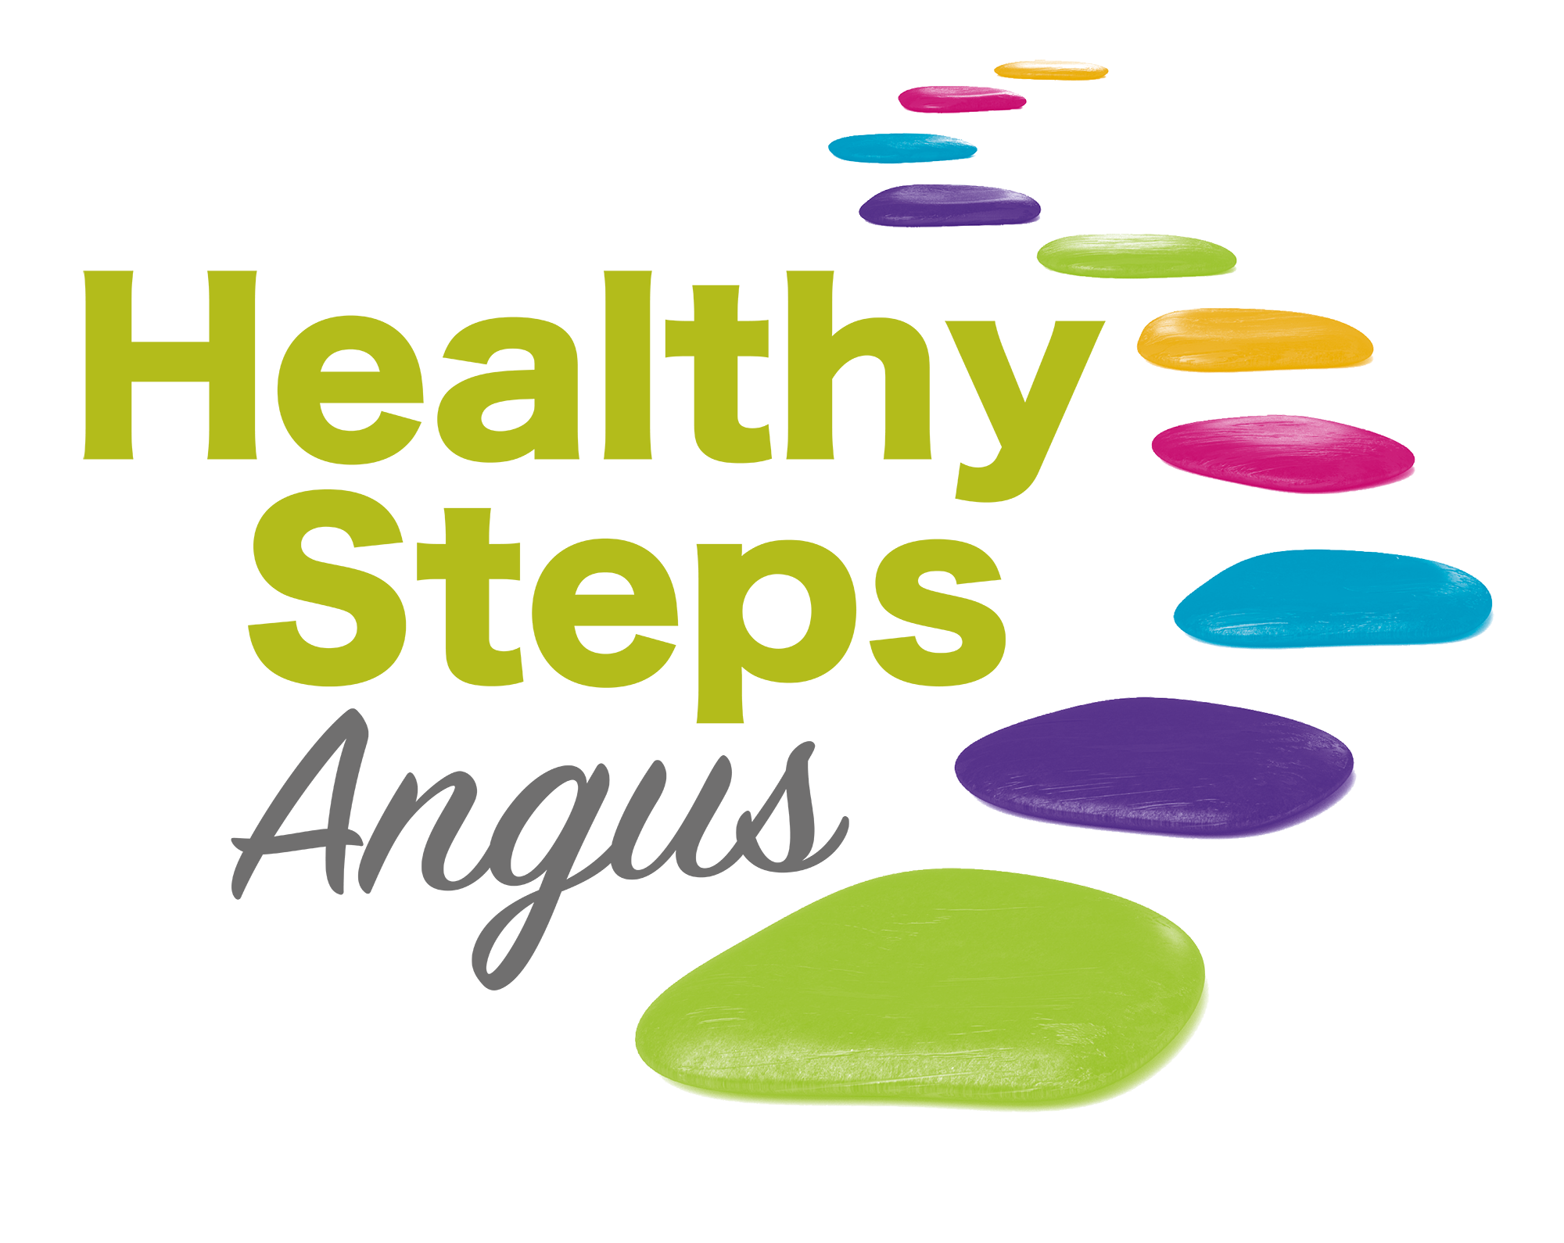
Healthy Steps Angus
Healthy Steps Angus provide regular, short, free, low-level walks led by trained staff or volunteers. These walks are suitable for those who are currently inactive, living with long term conditions or in recovery from illness, injury or at risk of isolation or just want to come and participate in fun physical activity, connect with nature and make new friends!
Walks take place across Angus from ANGUSalive facilities and within the community.
More information can be found here: https://angusalive.scot/countryside-adventures/healthy-steps-angus/
or to find your nearest walk, visit: https://www.pathsforall.org.uk/walking-for-health/health-walks

Pain Association Scotland
A national charity that delivers professionally led self-management pain education in the community.
Self-management means the individual being back in control, not the pain controlling them. This service is specifically designed to target those in the community who are affected by long term (Chronic Painful) conditions. It continues to address the non-medical issues which impact on people’s lives. The service is open to anyone regardless of diagnosis, at any time and provides a high quality staff led community based service for people burdened with all forms of chronic pain.
For more information on upcoming course dates in Angus, visit: https://painassociation.co.uk/tayside-group

Are You OK?
Developed by the Angus Mental Health & Wellbeing Network, Are You Ok? is a campaign running across Angus and provides mental health, wellbeing, suicide prevention and crisis support links – these can be used by individuals themselves, or to support those around them.
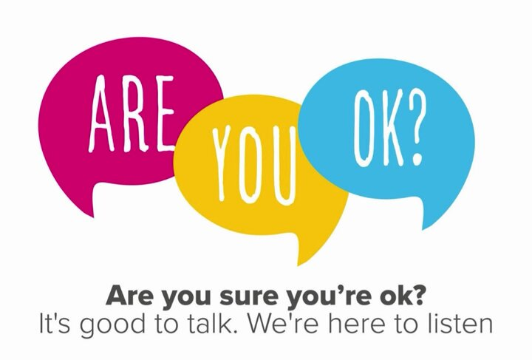
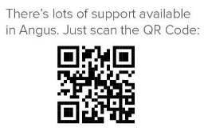

For more information use the QR codes below or visit: https://www.angus.gov.uk/social_care_and_health/mental_health_and_wellbeing/mental_health_wellbeing_suicide_prevention_and_crisis_support_links

